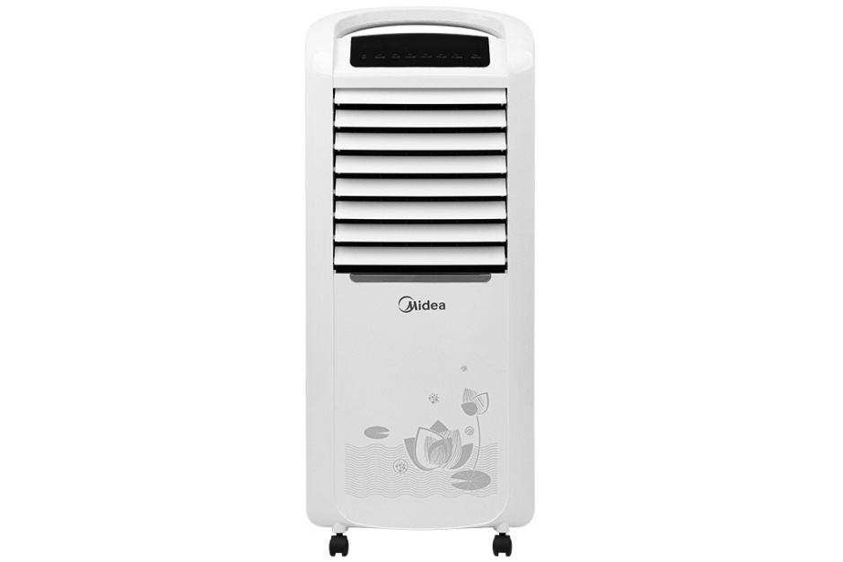**1.990.000₫**

~~5.000.000₫~~ -60%

**Technical specifications of Midea AC200-19WV air conditioner fan**

* Cooling range:

Room 20 - 30m²

* Wattage:

100W

* Wind speed:

3 wind levels

* Control:

There is a remote included with Touch

* Highest noise level:

50 dB

* Water bottle:

7 liters

* Utilities:

Has moving wheels Has cooling dry ice box Has display screen Turn off timer Creates air purifying ionizer Automatically turns off pump when water runs out Remote control 4-way automatic air swing left - right, up - down

* Size, volume:

Width 40 cm - Height 95.5 cm - Depth 30 cm - 11.44 kg

* Brand of:

China

* Made in:

China

Introducing the company 

- Chinese brand.

- Established in 1968. Started entering the household electrical market since 1980.

- As a giant corporation headquartered in Hong Kong, Midea has joint ventures with famous brands such as Carrie, Toshiba, Sanyo,...

- This is one of the large corporations that owns the most complete technological lines of washing machines, air conditioners, microwave ovens, dishwashers, refrigerators, rice cookers, induction cookers, air conditioner fan,...

- Midea products are very affordable, easy to use, and have many smart features friendly to Vietnamese consumers.

[**Midea air conditioner fan**](https://www.dienmayxanh.com/quat-dieu-hoa-midea)**comes with 2 boxes of dry ice to help cool faster and keep the air cool**

When purchasing a fan, you will receive 2 boxes of dry ice to use in the water tank to help reduce the temperature in the water. The lower the water temperature in the tank will help cool faster. Midea dry ice uses glacier raw materials. Compared to regular dry ice, Midea dry ice has a high density of snow and ice and stays cool for a long time.

[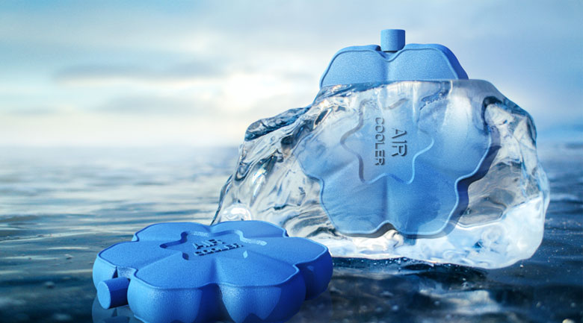](https://cdn.tgdd.vn/Products/Images/7498/218307/quat-dieu-hoa-midea-ac200-19wv-24.jpg)

[**Air conditioning fan**](https://www.dienmayxanh.com/quat-dieu-hoa)**with a capacity of 100W suitable for an area of ​​20 - 30m², effective cooling system**

Copper wire motor operates smoothly and durable.

**The noise level is less than 50 dB, which is less than the sound of a working office or a quiet hotel lobby**

**Negative ion generation function purifies the air in 1 touch, bringing fresher, cleaner air**

Negative ions help eliminate odors, increase oxygen in the blood, improve breathing, and protect family health.

[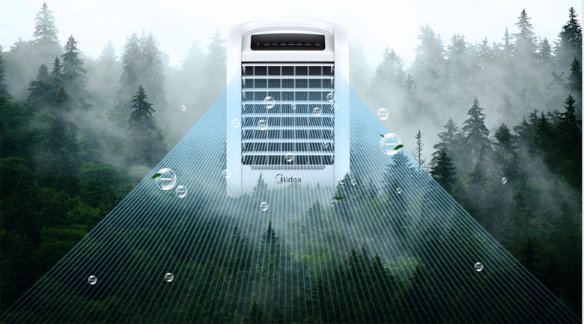](https://cdn.tgdd.vn/Products/Images/7498/218307/quat-dieu-hoa-midea-ac200-19wv-20.jpg)

See more:  [What is negative ion technology? Why are many companies using it?](https://www.dienmayxanh.com/kinh-nghiem-hay/cong-nghe-ion-am-la-gi-vi-sao-nhieu-hang-su-dung-c-1227318)

**The cooling pad is made of plant fibers that are very good for water absorption, air filtration, and effective cooling**

This air conditioning fan is not too large so it is very easy to disassemble and clean. Clean the cooling pad, dust filter, body, fan blades, water tank, etc. The fan motor part should use a small brush to sweep away dirt.

See more: [How to clean air conditioning fans](https://www.dienmayxanh.com/kinh-nghiem-hay/cach-ve-sinh-quat-dieu-hoa-970804)

**The water tank capacity is up to 7 liters and can be used for 5 - 6 hours**

Helps the air conditioner fan create cooling steam for a long time, users do not have to waste time refilling water many times. Automatically shuts off the pump when water runs out to help prolong its life.

When the water in the tank is empty, the pump will automatically shut off, this ensures the pump avoids damage when the user forgets to supply water when lacking, while the user still feels comfortable because of the wind. blows out like a regular electric fan.

**Touch control panel for easy operation, with multi-function remote**[**control**](https://www.dienmayxanh.com/quat-dieu-hoa?g=dieu-khien-tu-xa)

Turn off timer up to 12 hours, allowing you to sleep comfortably, without having to worry about not turning off the fan.

**4-way automatic air swing: horizontal - vertical, left - right increases cooling efficiency in large areas**

Notes to use air conditioning fans effectively:

- Air conditioner fans only have the ability to cool the air, not the cooling ability like an air conditioner.

- Placing a Midea steam fan in the corner of the room will help the wind spread throughout the room, providing a natural wind flow that is good for your health.

- Place the fan at least 20 cm away from the wall so that the fan has space to get air.

- Clean the fan regularly and the water in the tank is clean to avoid bacteria from growing, causing odors and affecting health.

- You should add water before plugging the power cord into the power source. If you are using a fan, turn it off and unplug the power cord before filling it with water, then start it up and use it again.

- If your house is near a road or industrial park, and the air in the room is dusty, turn on the ion generation mode integrated on the Midea AC200-19WV air cooler to filter the air and return the freshest space.

- Unplug the power cord when not using the fan to save more electricity.

[Midea AC200-19WV air conditioner fan](https://www.dienmayxanh.com/quat-dieu-hoa/quat-dieu-hoa-midea-ac200-19wv) is loved by many consumers thanks to its good quality and beautiful design, suitable for students in dormitories and small offices from 20 - 30m2 .